**AWS Lab Work**

**Select a region**

One of the most important steps is to select the desired AWS region. This can be done from the top navigation bar of the AWS Console.

## Navigate to the EC2 Console

Once you select the desired AWS region, go to the EC2 Console. From the same landing page, search for EC2 (Figure 1). Your landing page in the management interface will likely display EC2 among the most commonly used services in the account.

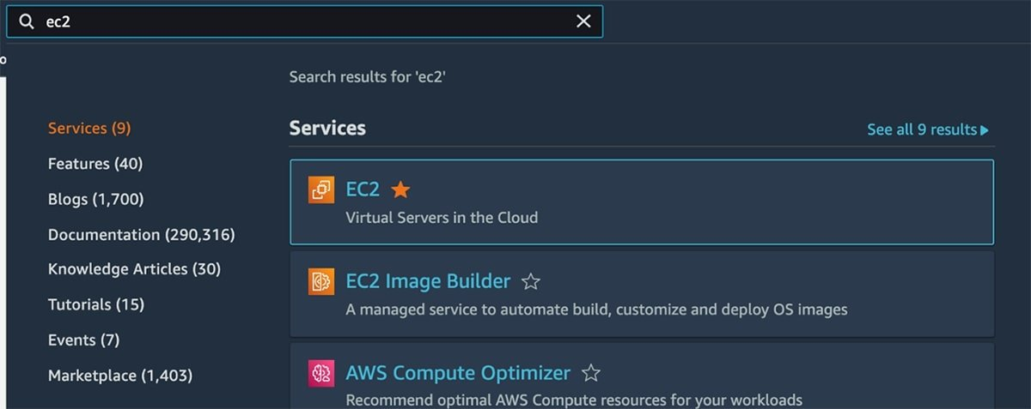

Figure 1. Search for EC2 in the search bar of the AWS Console.

Once you arrive at the EC2 Console, from the left navigation menu, choose the **Instances** option.

Under **Instances** is a list of the EC2 instances deployed in the account. There is also a **Launch instances** button on the top right section of this page; clicking on that button brings you to the EC2 instance launch flow (Figure 2).

The top right section of this page in the EC2 Console displays a Launch Instances button.

Figure 2. Selecting Launch Instances brings you to an EC2 instance launch flow.

**How to check the regions**

**:- Available regions:-** different regions have different billing notes....and cost is set according to it.

we can see payment bill in balance in payment to be paid

Then give username

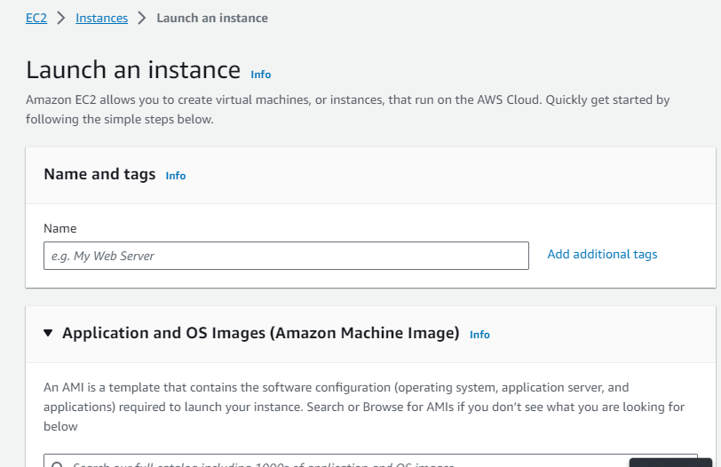

We have to generate a key pair: it contain encoding of SSA 256

In this we have to select the one which is freely available

Now select OS.....select that which are for free

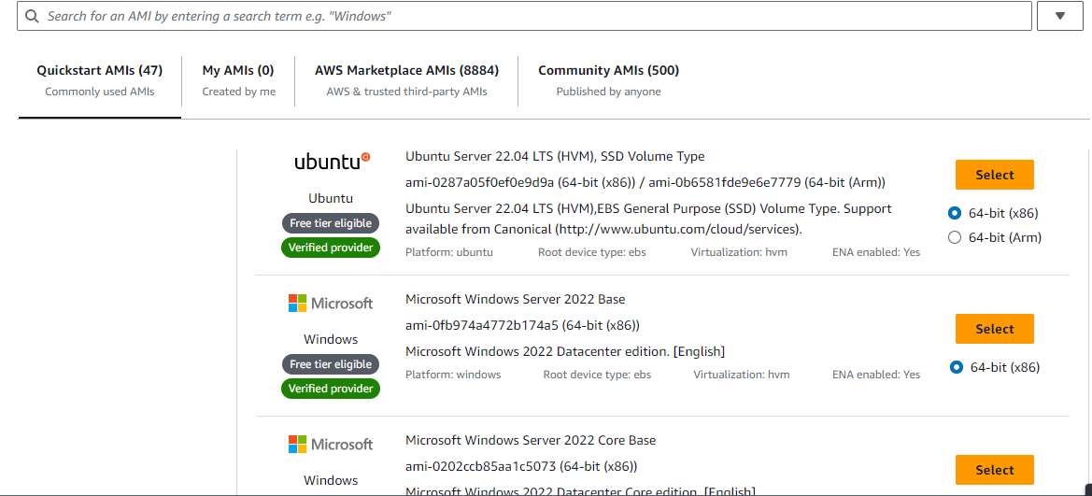

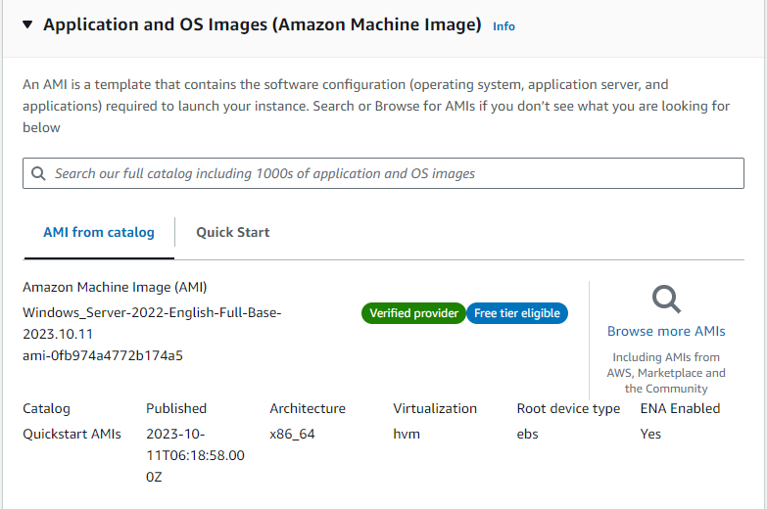

In instance type will be select T2 micro

## Enable SSH access with a key

The key is used to enable Secure Shell (SSH) access into the EC2 instance.

With Windows instances, the private EC2 key helps generate an admin password to access the instance. AWS stores a copy of the public key inside the EC2 instance. Users keep the private key.

It's the developer's responsibility to [store the generated key file in a secure location](https://www.techtarget.com/searchsecurity/answer/SSH-security-risks-Assessment-and-remediation-planning), given that this file enables someone to access the EC2 instance and run commands in it.

Once this step is completed, the EC2 instance goes into a pending state, which typically lasts less than one minute. The instance then transitions into a running state, and it's ready to be used.

Now generate a key pair and give the name....this key pair helps in in decrypting the password when we launch the instance on other

Then file will be downloaded with .pem extensions

Select RDP traffic form(for us master users)

HTTPS and HTTP(for only view users)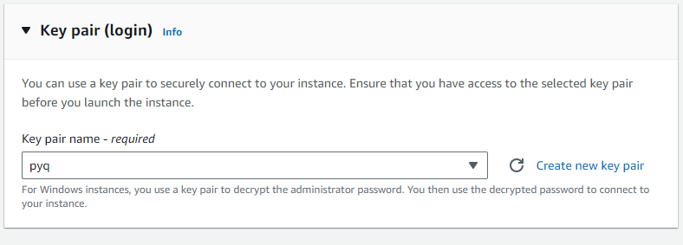

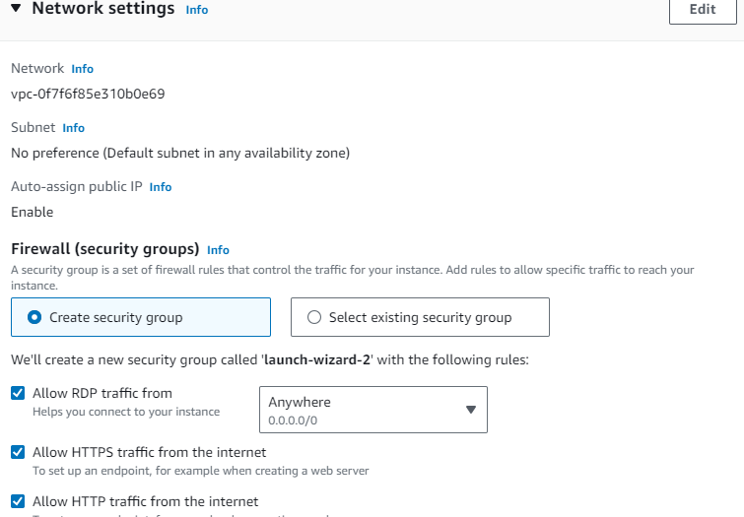

**Now configure the storage**

Now we will give configurations 1x '30' and GiB 'gp2' Root volumes’

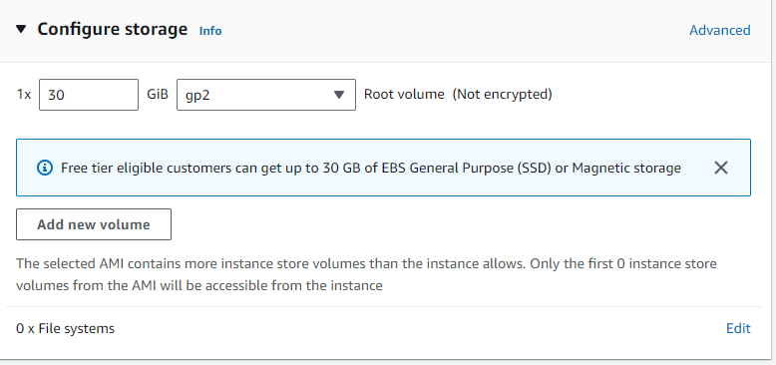

By selecting the no of instances we have to click on the create instance

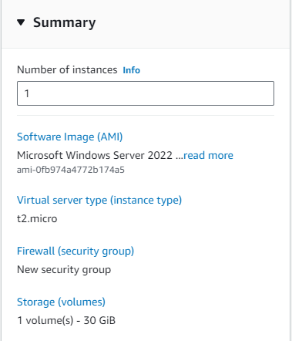

After that we have to click on the launch instance

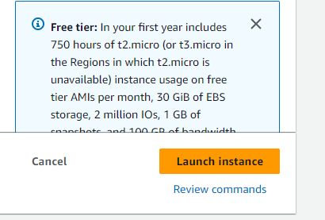

**Instance creates Successfully**

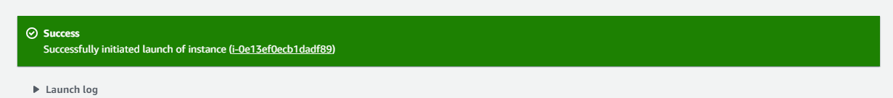

We will check that our systems are connected to our personal mobile connections......coz it will not run on institution's internet connection

If your instance failed again.....then change the region

If instance launched successfully then check for two things

1. Instance state= running

2. Status check - initialization - 2/2 checks passed

Here where we have to check whether the instance is running or not

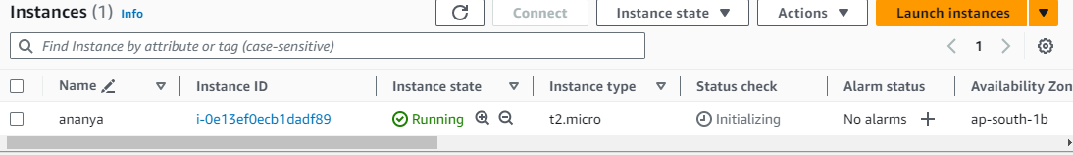

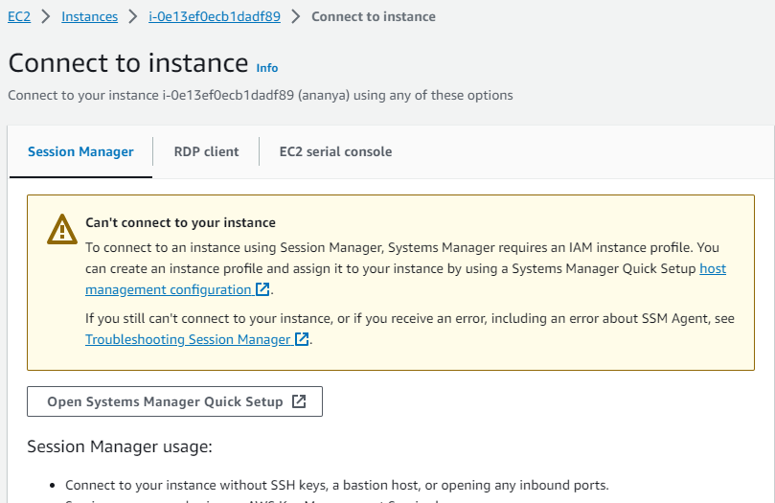

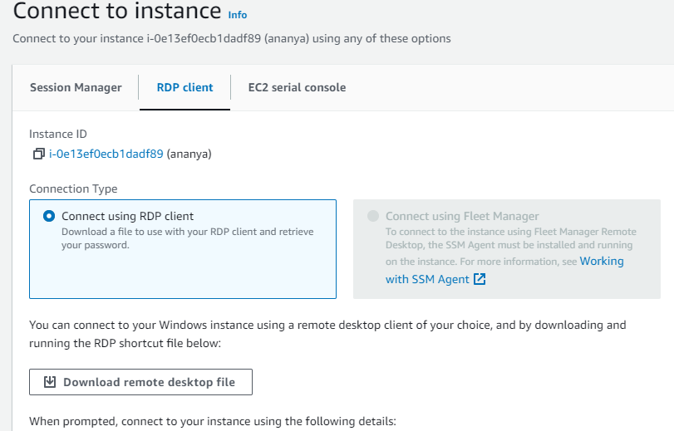

Now switch to RDP client

Now click on window button and search for rdc

Copy the public DNS and Username

and paste in in RDC

Now click on get password...there click on get password......and click on upload private key and file will be uploaded

And now file will be uploaded and press on decrypt password

now password will be given and then copy it

Return to remote desktop after you click on connect

there will be a certificate verification that you have to run the instance or not, select yes and Launch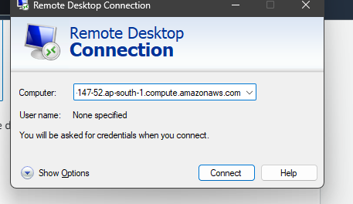

After scrolling to right There will be a public IPv4 address and if we do any hosting on that instance then any user or client can access that

then for closing or terminating the instance go to 'instance state' a pop up menu will appear which will have options for stopping instance , terminating instance and many more

Then select on terminate instance and a green line will appear which says " Instance successfully terminated ".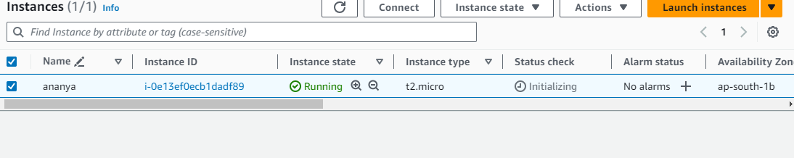

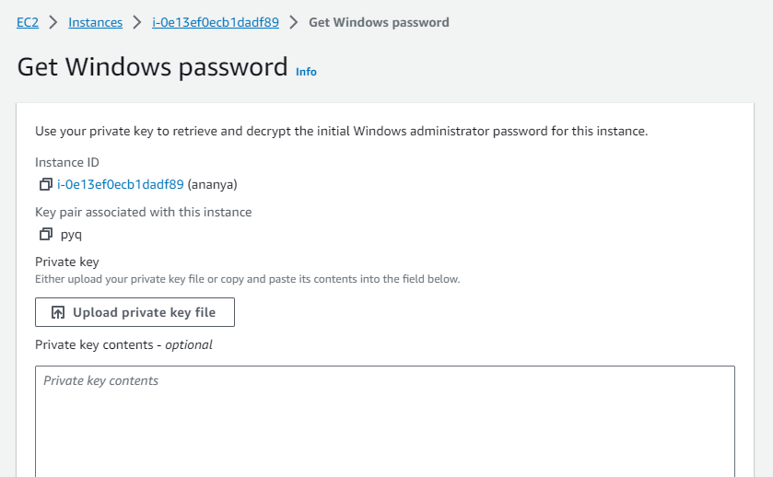

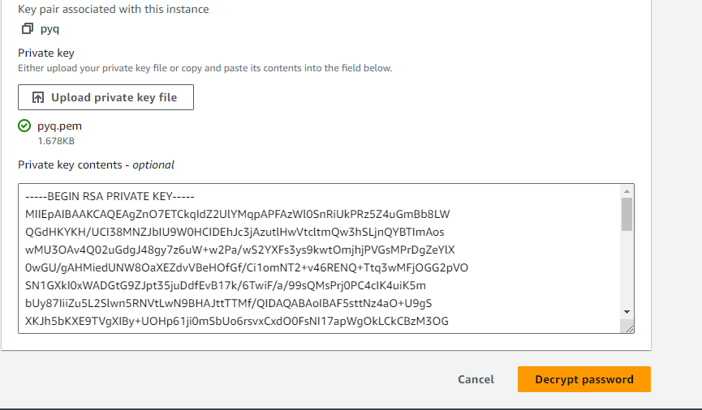

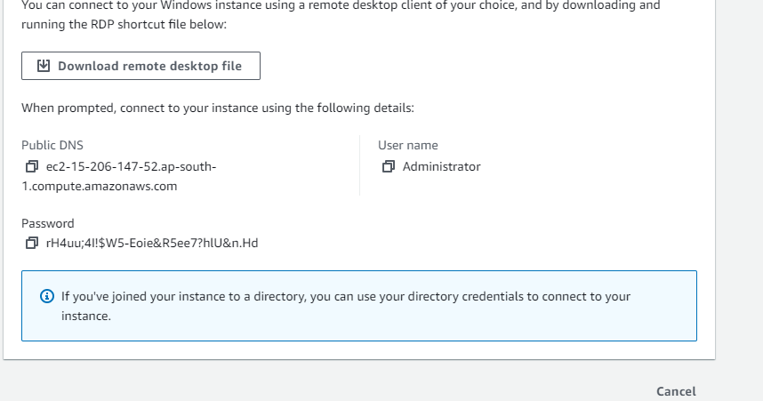

**How to create the bucket**

It is used for Storing and retrieving any amount of data

Click on create bucket

Select region.....you can use default one

Encryption type:- for data encryption

Tags:- It is a grouping methods for grouping the most used services for billing purpose

After that a new bucket will be created

On clicking on upload option windows explorer will be opened and you can select the folder or file to upload

Now for termination

If nothing is stored the billing will not be done

We can also select empty for emptying everything and billing will be stopped

last we can select our bucket and select and next page will open....enter you bucket name and select delete and your billing will be stopped

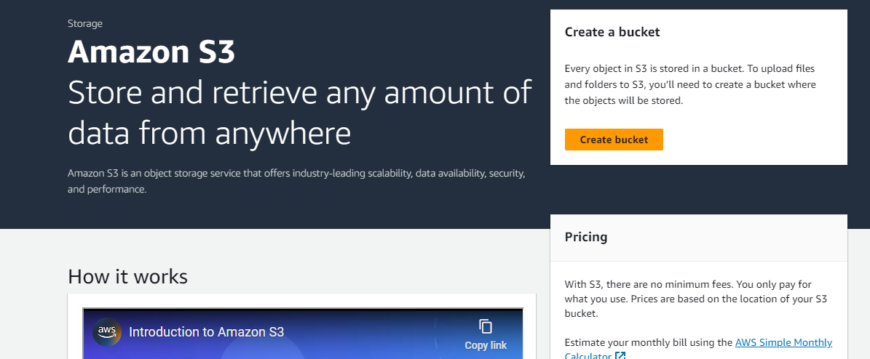

Click on the create bucket

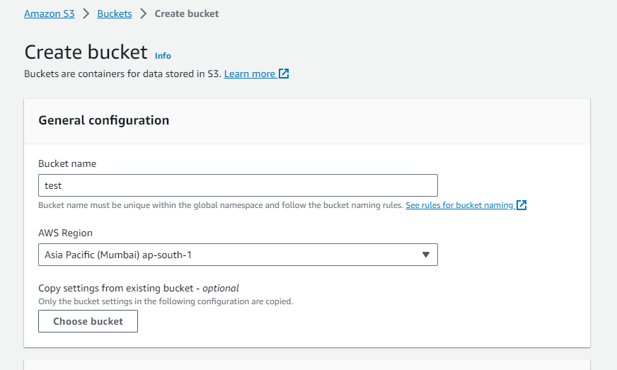

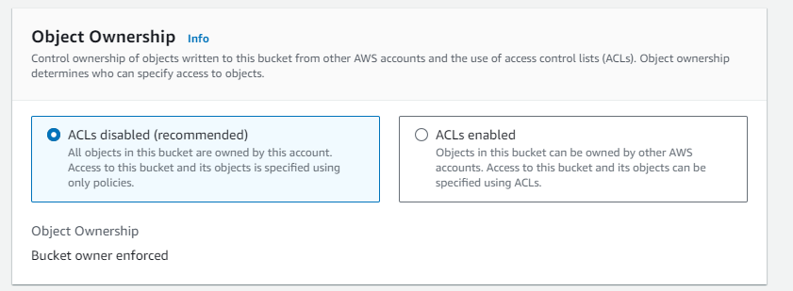

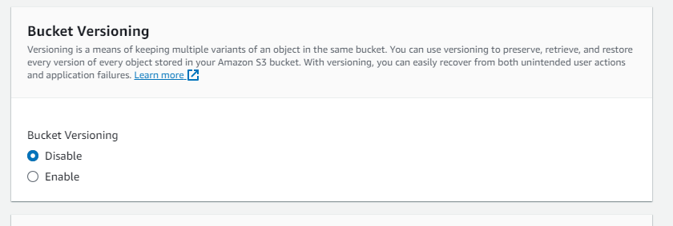

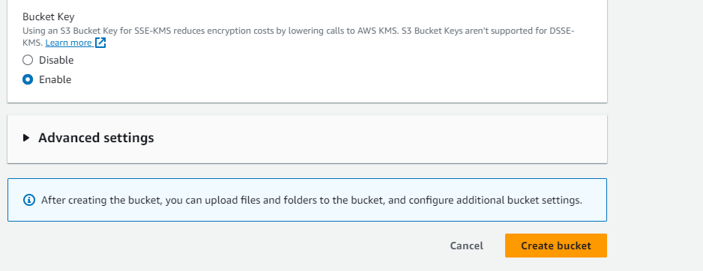

After this we have to click on the create Bucket

After bucket creation

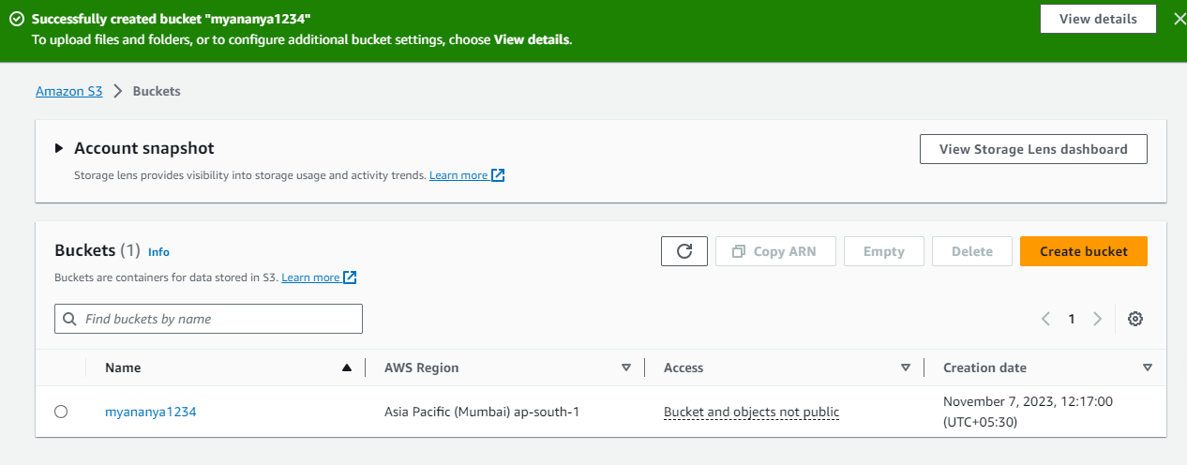

For deleting the bucket

